1. Use –“Inside_Sales.csv” to create chart below. Show largest selling products and also show what % of sales is coming from which regions.

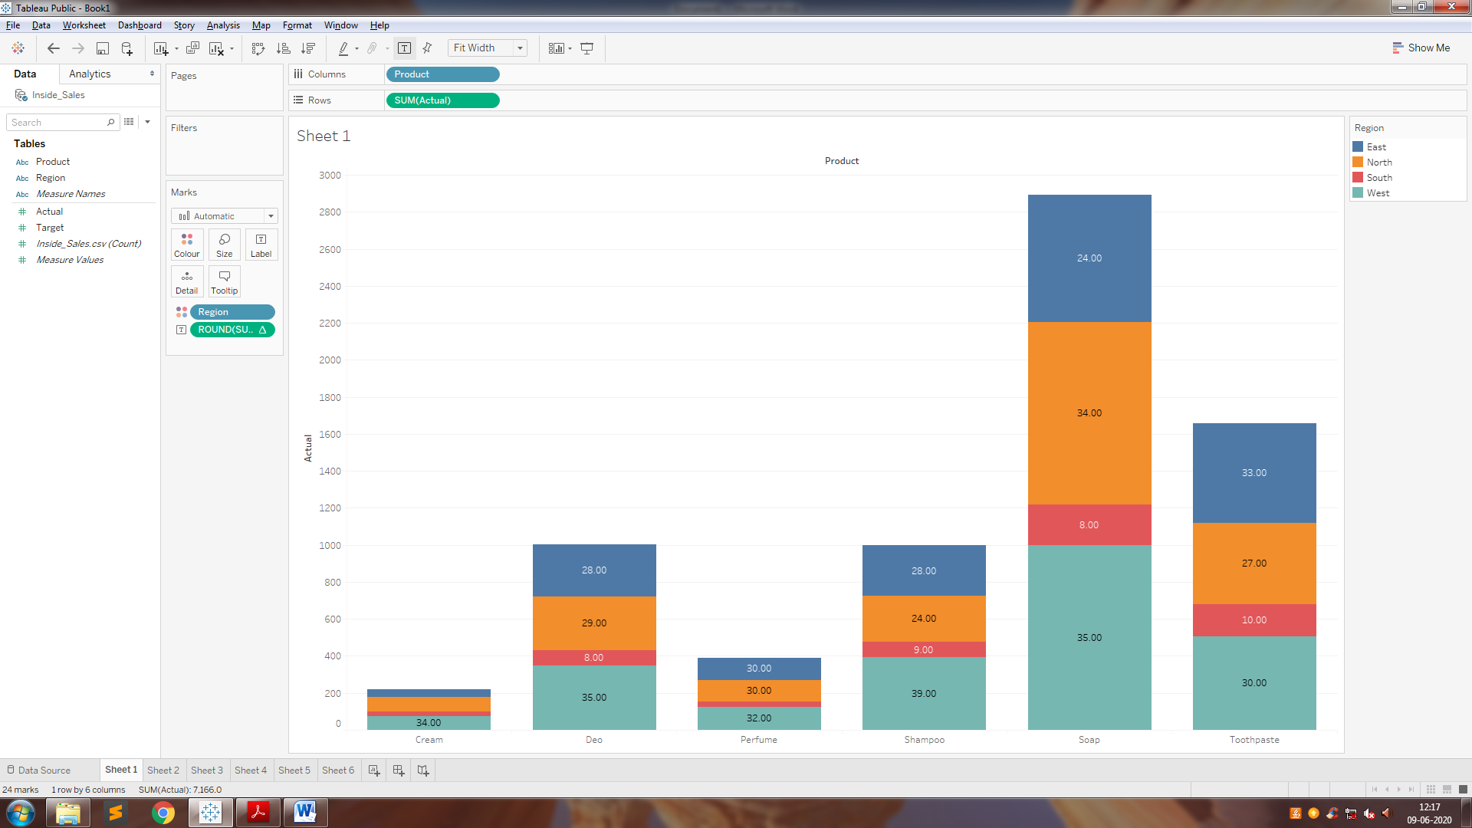

2. Convert the chart created in previous slide to 100% staked.

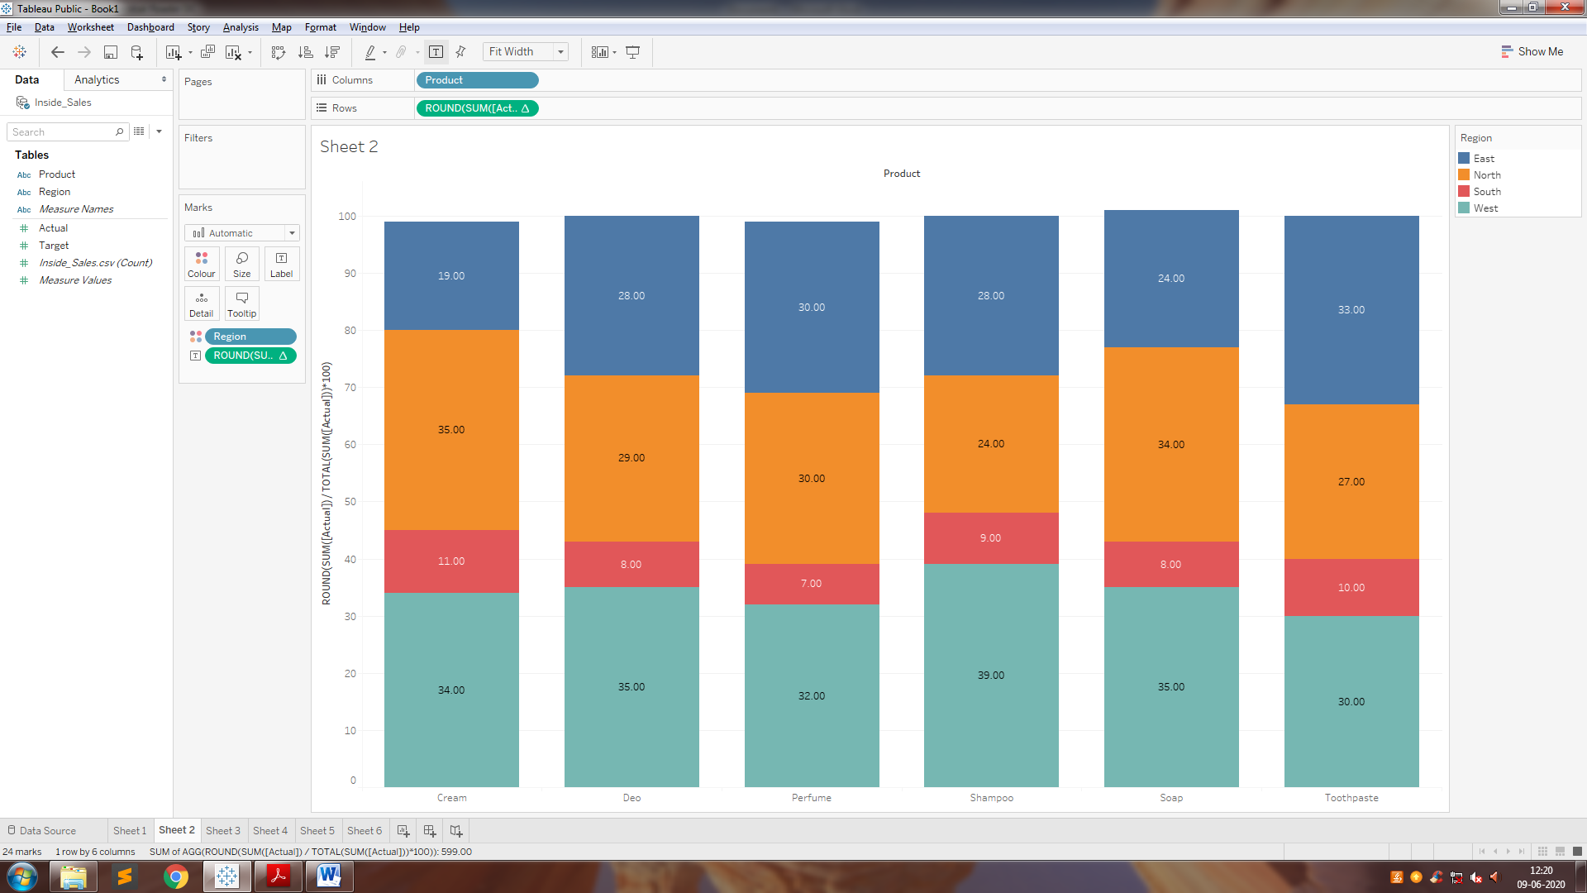

3. Create a side by side bar to compare Actual vs Target sales of different products.

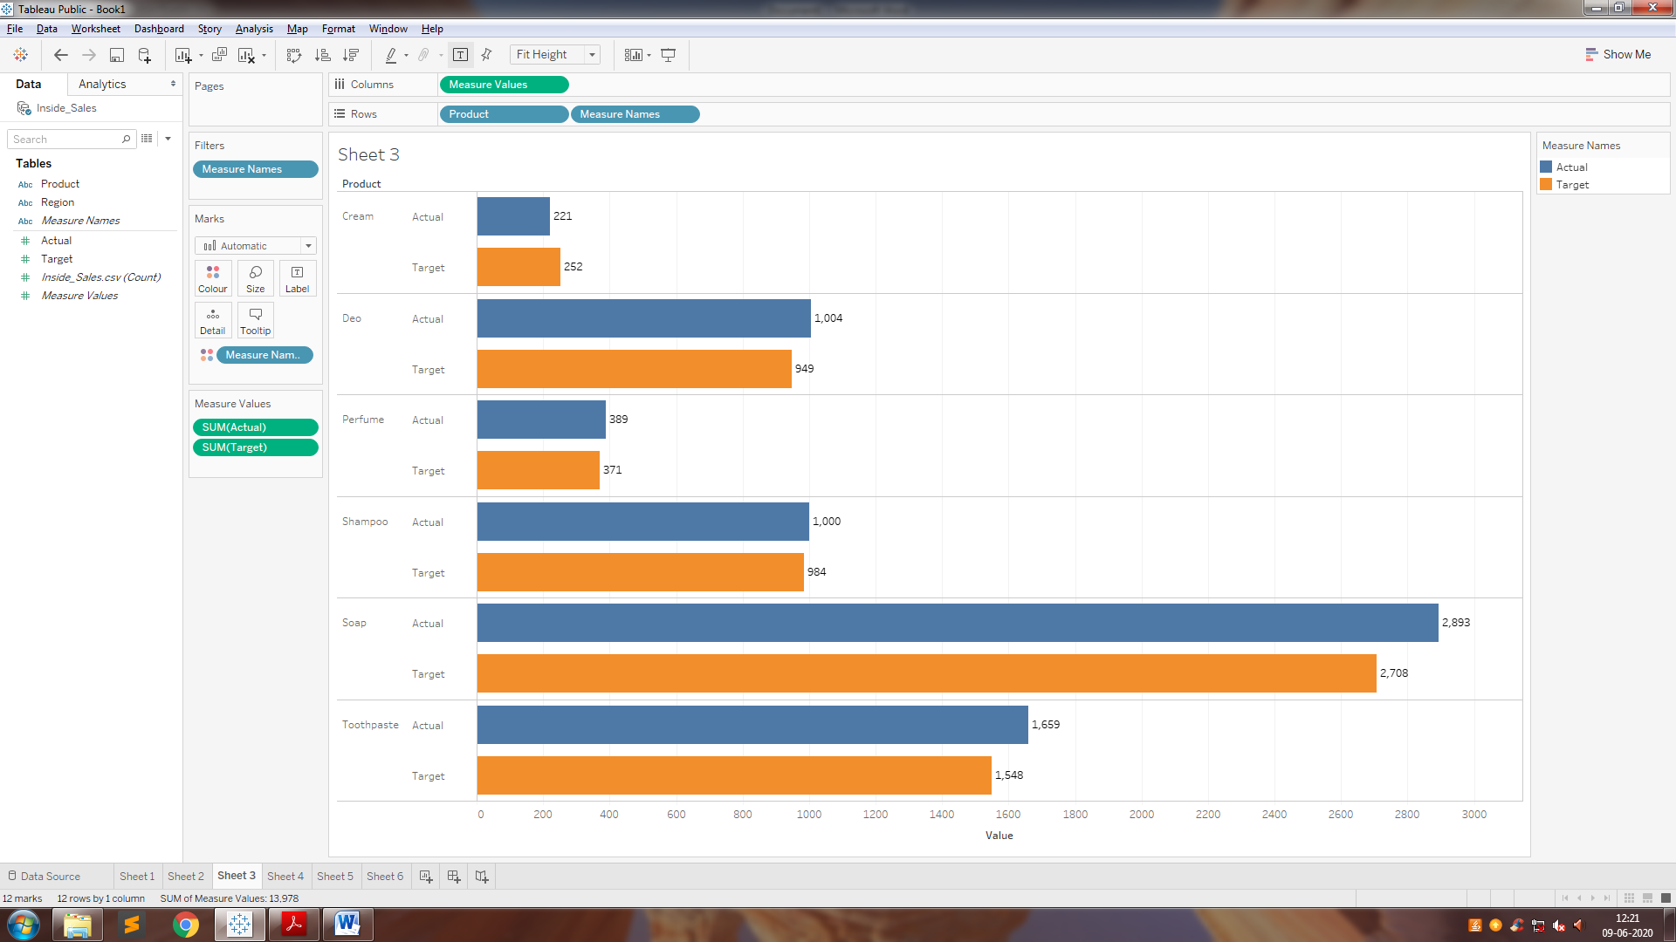

4. Create a tree map to show largest selling regions.

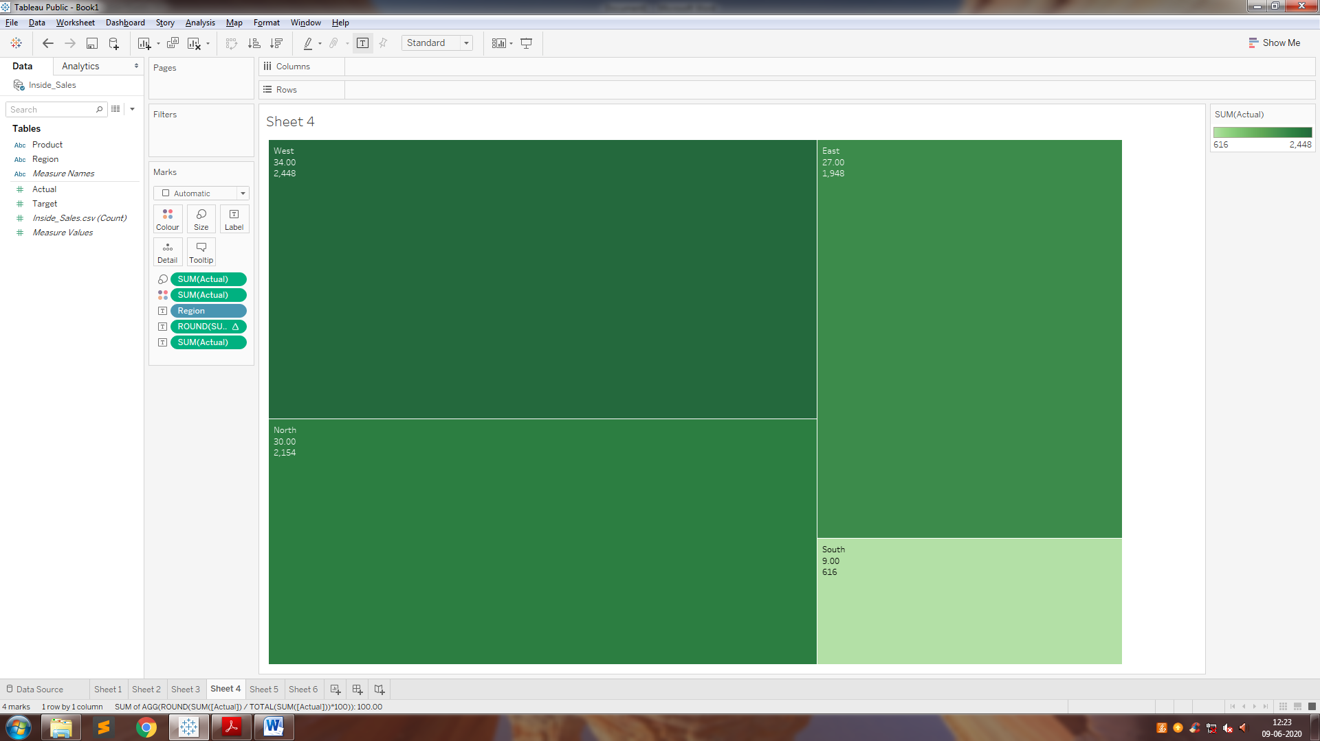

5. Create a packed bubble to show product sales.

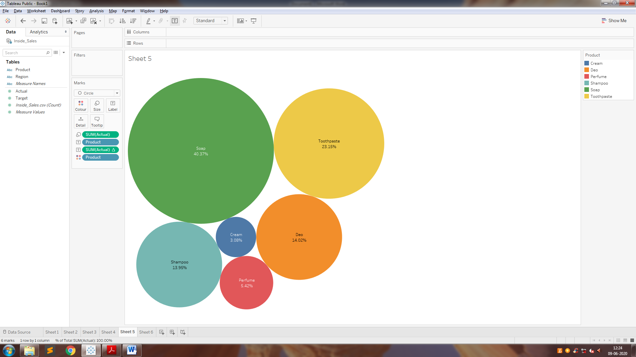

6. Create a side by side circle chart to compare actual vs target sales of different products.

